

Project Design Phase-II Technology Stack (Architecture s Stack)

Date | 18 February 2026
Team ID | LTVIP2026TMIDS4411
Project Name | ShopEZ:One-Stop Shop for Online Purchases
Maximum Marks | 4 Marks

Technical Architecture Overview
ShopEZ is a full-stack e-commerce platform built using the MERN stack (MongoDB, Express.js, React.js, Node.js). The architecture ensures scalability, modularity, and secure data flow between components.
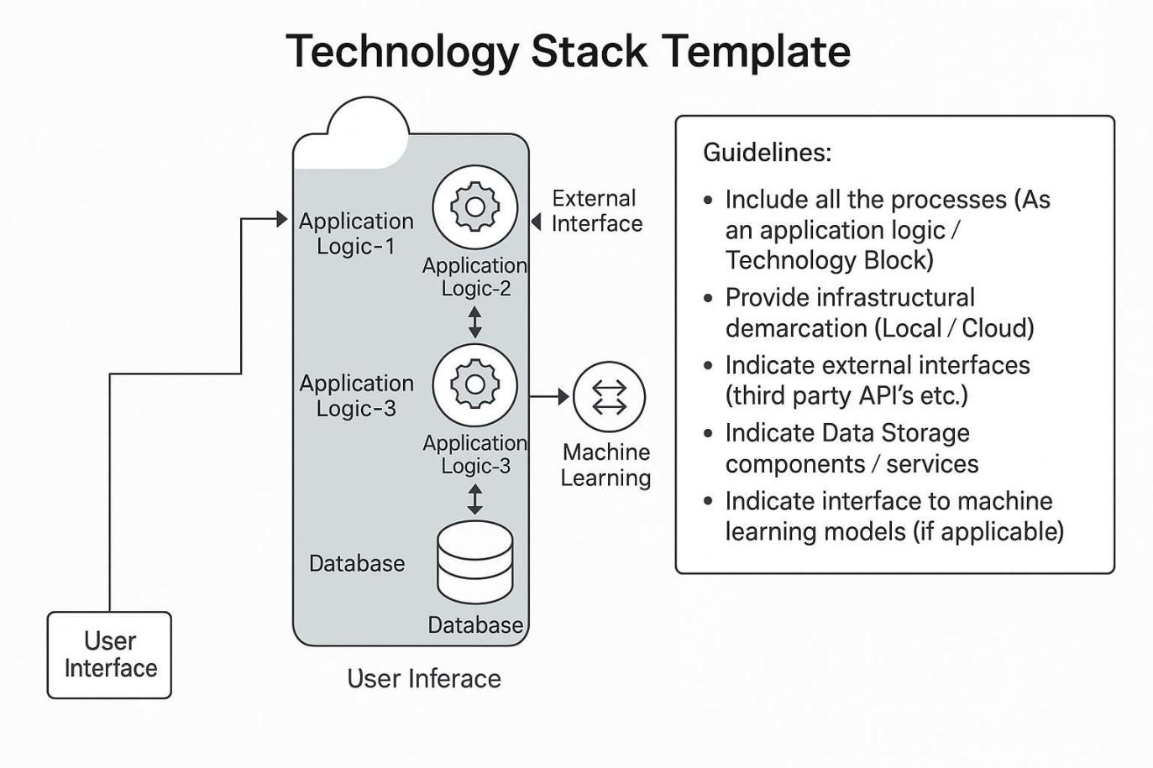



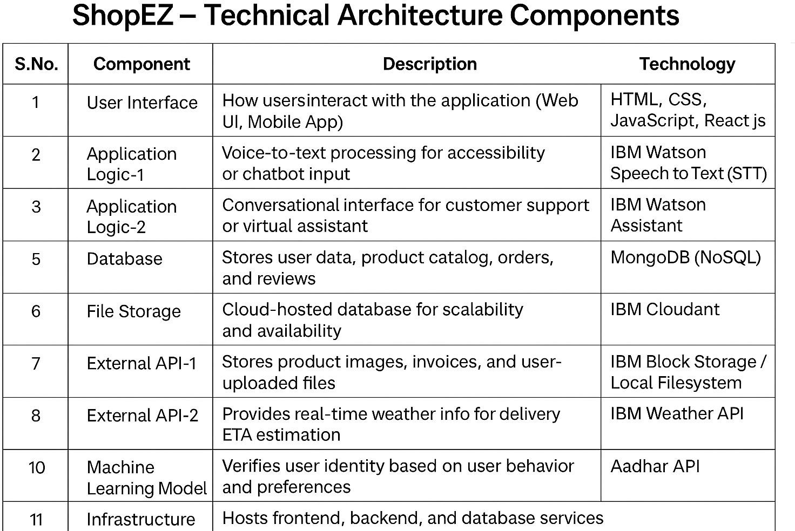



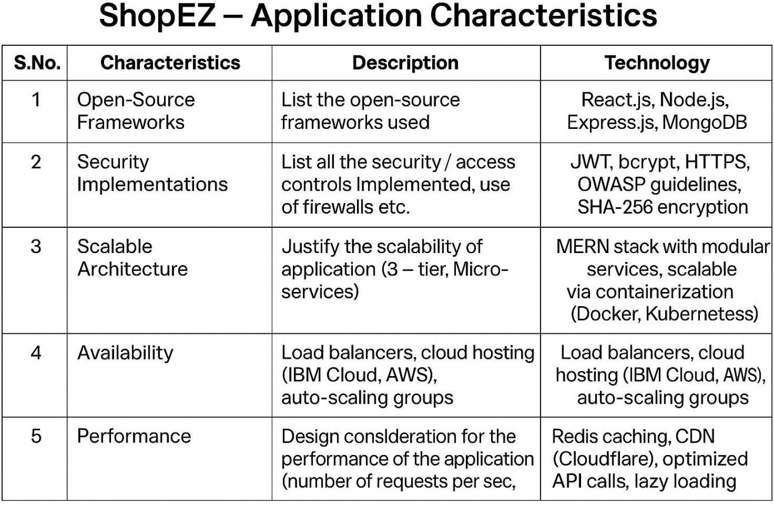

References
https://c4model.com/
https://developer.ibm.com/patterns/online-order-processing-system-during-pandemic/ https://www.ibm.com/cloud/architecture
https://aws.amazon.com/architecture
https://medium.com/the-internal-startup/how-to-draw-useful-technical-architecture- diagrams-2d20c9fda90d
https://github.com/sameekshaapatel/Shopez-E-commerce-Application- sameeksha/blob/main/README.md
https://nme.smartinternz.com/saas-guided-project/1/shopez-e-commerce-application https://www.cliffsnotes.com/study-notes/12909922

